**Roll no: 230701085**

**Exp No:3.a** Conduct an experiment to show data visualization using line plot.

**Description:** Take any sample data either through csv file or data fetched directly through

code.

**CODE:**

import matplotlib.pyplot as cricket

Overs=list(range(5,51,5))

Indian_Score=[30,55,90,129,165,200,239,270,310,350]

Srilankan_Score=[25,70,90,120,140,170,195,220,255,279]

cricket.plot(Overs,Indian_Score)

cricket.plot(Overs,Srilankan_Score)

cricket.title("INDIA Vs SRILANKA")

cricket.xlabel("Overs")

cricket.ylabel("Scores")

**OUTPUT:**

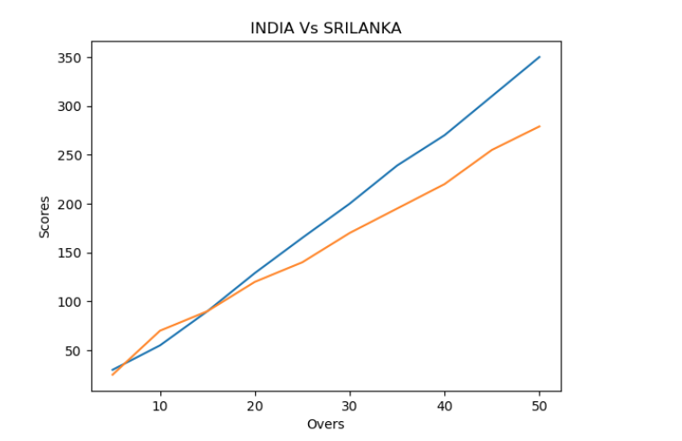

**Exp No:3.b** Conduct an experiment to show data visualization using bar chart.

**Description:** Take any sample data either through csv file or data fetched directly through

code.

**CODE:**

import matplotlib.pyplot as hscmark

import numpy as np

Names = ['KARAN', 'PREETA', 'VEER','BANI']

xaxis = np.arange(len(Names))

Percentage_hsc = [96, 75, 45, 81]

hscmark.bar(Names, Percentage_hsc)

hscmark.xticks(xaxis, Names, rotation=45)

hscmark.xlabel('Names of Pupil')

hscmark.ylabel('Percentage')

hscmark.title('Comparison of HSC Percentage', fontsize=15, color='green')

hscmark.show()

**OUTPUT:**

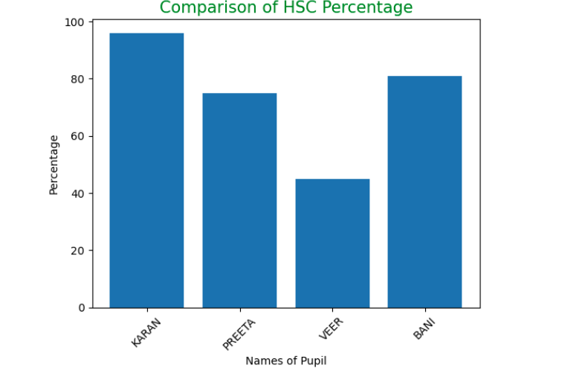

**Exp No:3.c** Conduct an experiment to show data visualization using pie chart

**Description:** Take any sample data either through csv file or data fetched directly through code.

**CODE:**

import numpy as np

import matplotlib.pyplot as election

roles=['Candidate 1','Candidate 2','Candidate 3','Candidate 4']

count=np.array([100,65,23,10])

colours = ['red','blue','green','yellow']

election.pie(count,labels=roles)

election.legend()

election.title("Election Result")

election.show()

**OUTPUT:**

